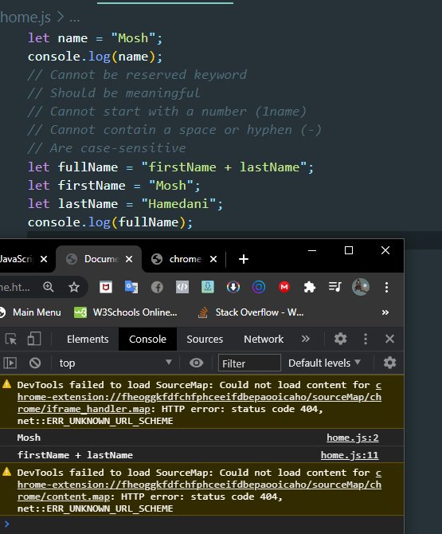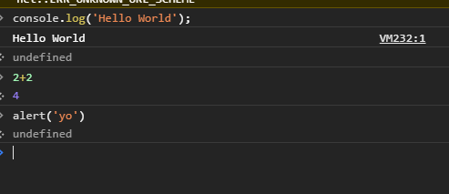

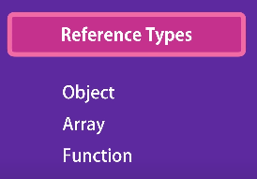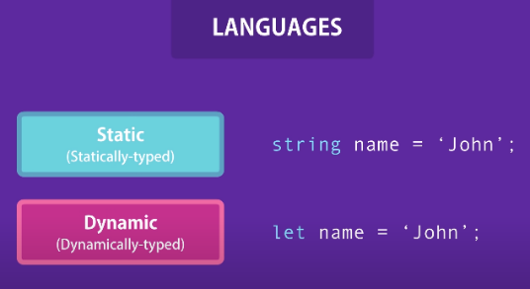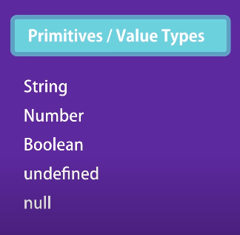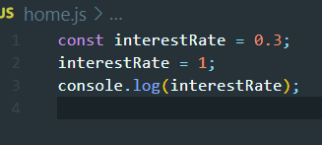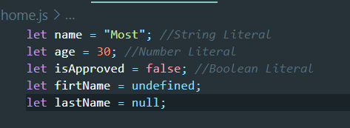

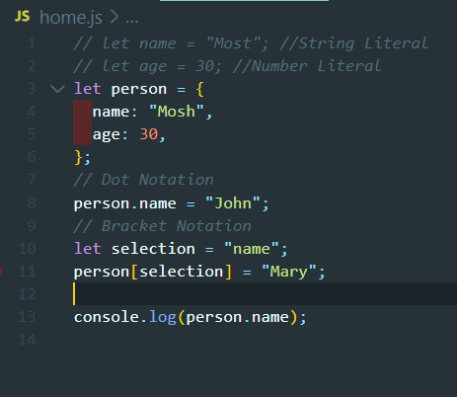 To remove press ctrl +L

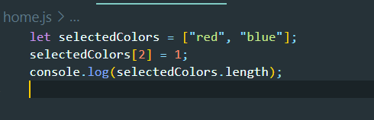

Array- Used to store the lists

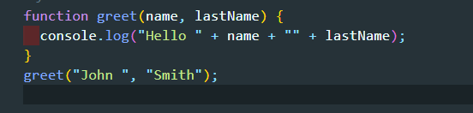

Functions – fundamental block in javascript

Performs task and calculate value

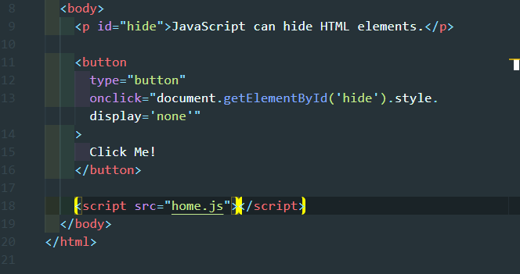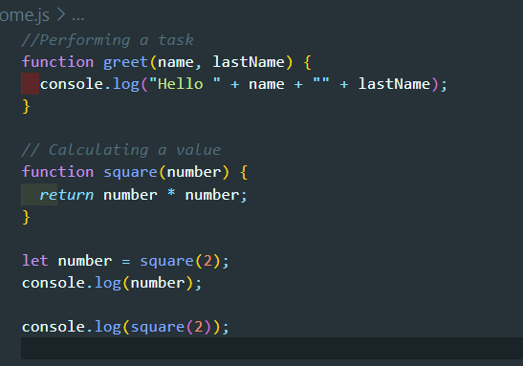Hiding elements

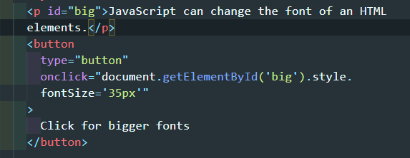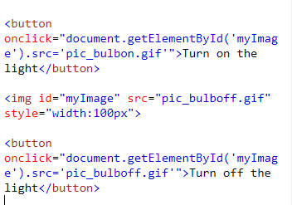Bulb on/off

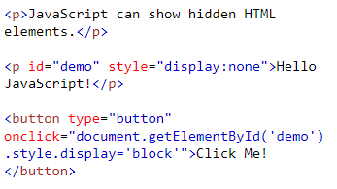

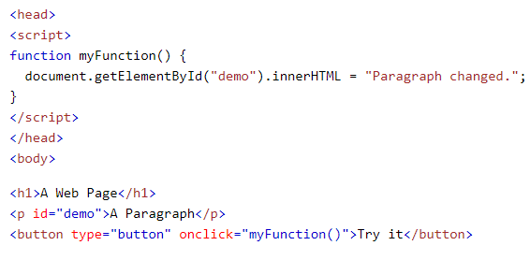

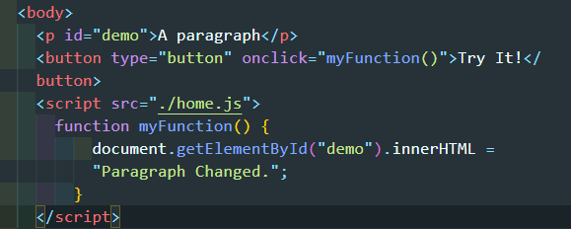

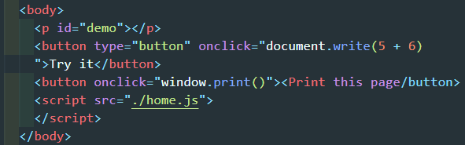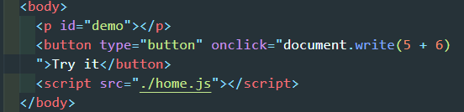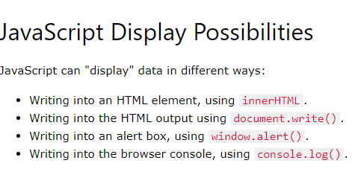

this is my cheat sheet for strings and arrays

feel free to use it or just copy into a text file :)

<---------- string methods ---------->

1.charAt(index) // Returns the character at the specified index (position)

2.charCodeAt(index) // Returns the Unicode of the character at the specified index

3.concat(str1,[...]) // Joins two or more strings, and returns a new joined strings

4.endsWith(searchVal,[length]) // Checks whether a string ends with specified string/characters

5.fromCharCode(n1,[...]) // Converts Unicode values to characters

6.includes(searchVal,[start]) // Checks whether a string contains the specified string/characters

7.indexOf(searchVal,[start]) // Returns the position of the first found occurrence of a specified value in a string

8.lastIndexOf(searchVal,[start]) // Returns the position of the last found occurrence of a specified value in a string

9.localeCompare(str) // Compares two strings in the current locale

10.match(regex) // Searches a string for a match against a regular expression, and returns the matches

11.repeat(count) // Returns a new string with a specified number of copies of an existing string

12.replace(searchVal,newVal) // Searches a string for a specified value, or a regular expression, and returns a new string where the specified values are replaced

13.search(searchVal) // Searches a string for a specified value, or regular expression, and returns the position of the match

14.slice(start,[end]) // Extracts a part of a string and returns a new string

15.split([separator],[limit]) // Splits a string into an array of substrings

16.startsWith(searchVal,[start]) // Checks whether a string begins with specified characters

17.substr(start,[length]) // Extracts the characters from a string, beginning at a specified start position, and through the specified number of character

18.substring(start,[end]) // Extracts the characters from a string, between two specified indices

19.toLocaleLowerCase() // Converts a string to lowercase letters, according to the host's locale

20.toLocaleUpperCase() // Converts a string to uppercase letters, according to the host's locale

21.toLowerCase() // Converts a string to lowercase letters

22.toString() // Returns the value of a String object

23.toUpperCase() // Converts a string to uppercase letters

24.trim() // Removes whitespace from both ends of a string

25.valueOf() // Returns the primitive value of a String object

<---------- end of string methods ---------->

<---------- Arrays ---------->

1.concat(arr1,[...]) // Joins two or more arrays, and returns a copy of the joined arrays

2.copyWithin(target,[start],[end]) // Copies array elements within the array, to and from specified positions

3.entries() // Returns a key/value pair Array Iteration Object

4.every(function(currentval,[index],[arr]),[thisVal]) // Checks if every element in an array pass a test

5.fill(val,[start],[end]) // Fill the elements in an array with a static value

6.filter(function(currentval,[index],[arr]),[thisVal]) // Creates a new array with every element in an array that pass a test

7.find(function(currentval,[index],[arr]),[thisVal]) // Returns the value of the first element in an array that pass a test

8.findIndex(function(currentval,[index],[arr]),[thisVal]) // Returns the index of the first element in an array that pass a test

9.forEach(function(currentval,[index],[arr]),[thisVal]) // Calls a function for each array element

10.from(obj,[mapFunc],[thisVal]) // Creates an array from an object

11.includes(element,[start]) // Check if an array contains the specified element

12.indexOf(element,[start]) // Search the array for an element and returns its position

13.isArray(obj) // Checks whether an object is an array

14.join([seperator]) // Joins all elements of an array into a string

15.keys() // Returns a Array Iteration Object, containing the keys of the original array

16.lastIndexOf(element,[start]) // Search the array for an element, starting at the end, and returns its position

17.map(function(currentval,[index],[arr]),[thisVal]) // Creates a new array with the result of calling a function for each array element

18.pop() // Removes the last element of an array, and returns that element

19.push(item1,[...]) // Adds new elements to the end of an array, and returns the new length

20.reduce(function(total,currentval,[index],[arr]),[initVal]) // Reduce the values of an array to a single value (going left-to-right)

21.reduceRight(function(total,currentval,[index],[arr]),[initVal]) // Reduce the values of an array to a single value (going right-to-left)

22.reverse() // Reverses the order of the elements in an array

23.shift() // Removes the first element of an array, and returns that element

24.slice([start],[end]) // Selects a part of an array, and returns the new array

25.some(function(currentval,[index],[arr]),[thisVal]) // Checks if any of the elements in an array pass a test

26.sort([compareFunc]) // Sorts the elements of an array

27.splice(index,[quantity],[item1,...]) // Adds/Removes elements from an array

28.toString() // Converts an array to a string, and returns the result

29.unshift(item1,...) // Adds new elements to the beginning of an array, and returns the new length

30.valueOf() // Returns the primitive value of an array

<---------- end of Arrays ---------->

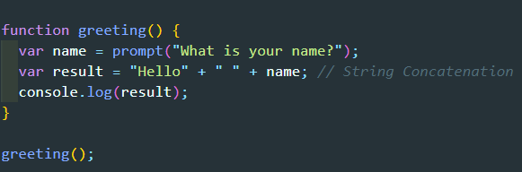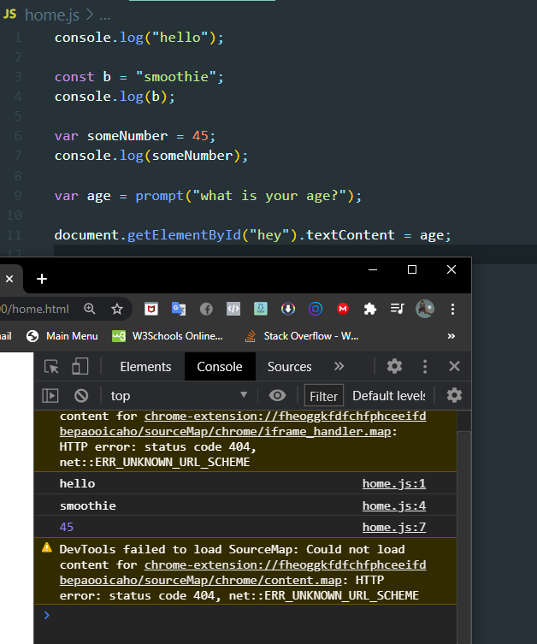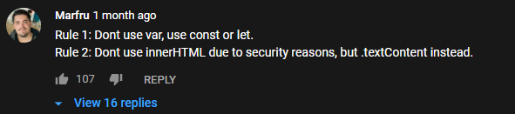

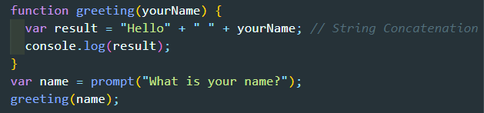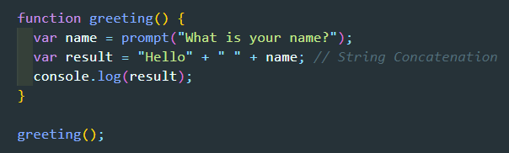

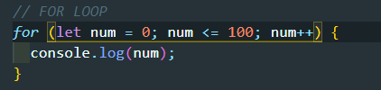

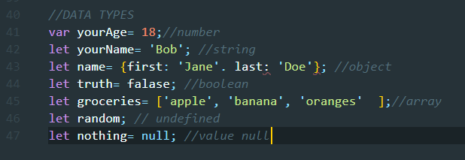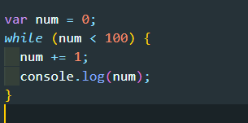

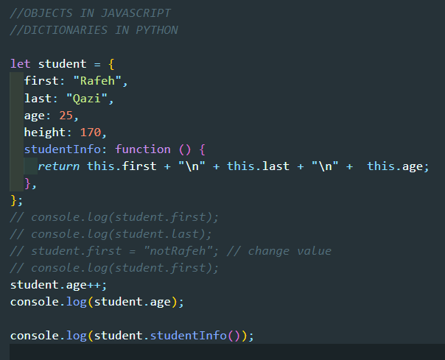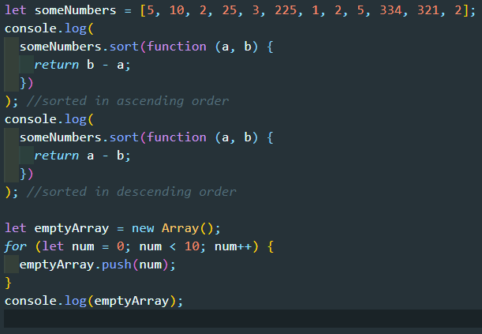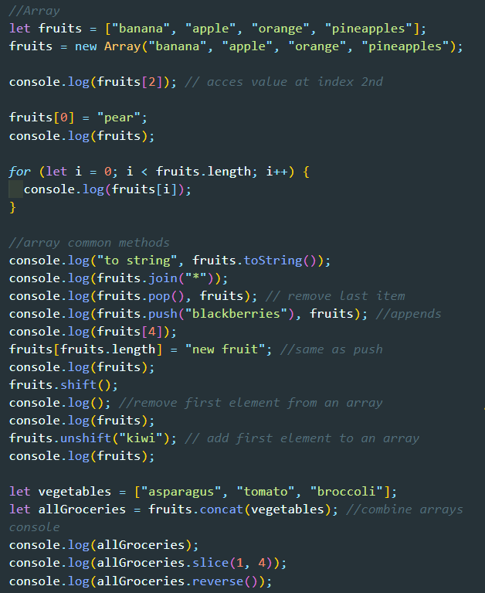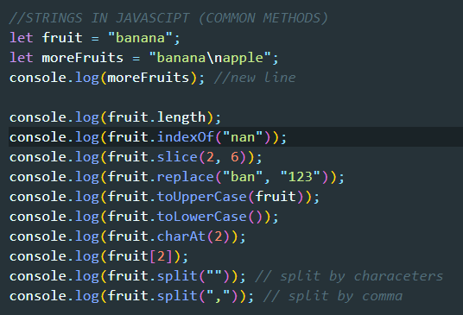

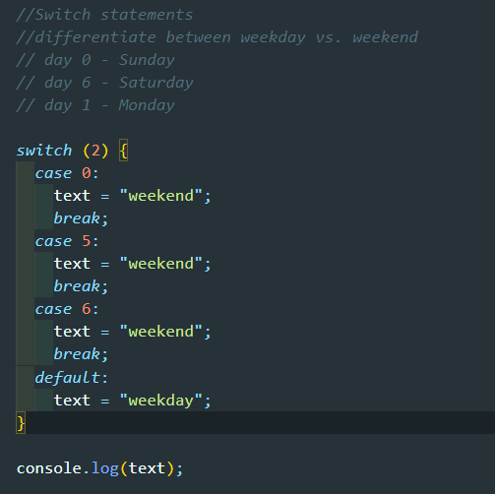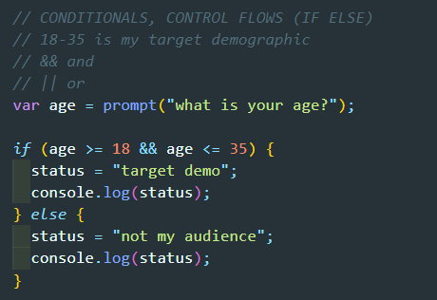

\

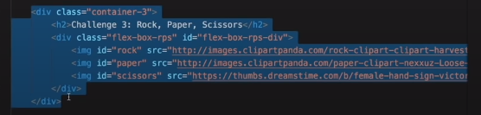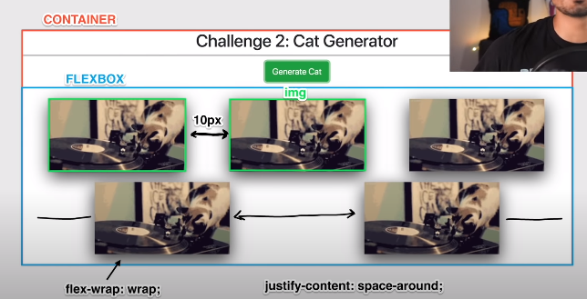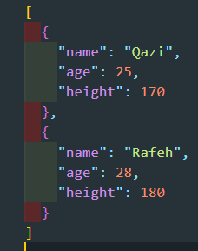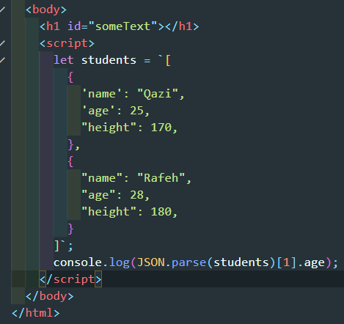JSON

